How to turn in
Assignments on Google Classroom
First of all, 99% of the time you are going to just click “Mark as done” on the assignment page to turn in something that I put on there for you to do. Look at the picture to see what I mean…
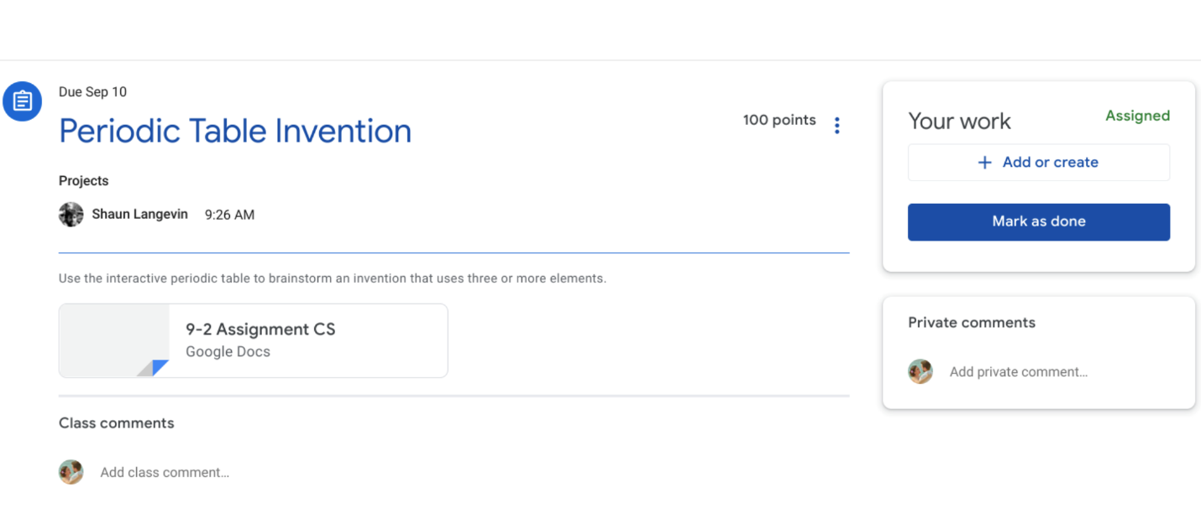
If you click on “view assignment”, this is what you’ll see. You can make a comment to me, if you need to, right below the button you click to turn it in. If you are turning it in late, this would be a good place to explain your reasons. You can also ask questions here before you turn something in, if you need help with something you don’t understand.
If you have to upload something, like a picture of a map or a scanned document, click “Add or create” and do what it tells you. You will have to have the thing you are uploading to Classroom already in your Google Drive or at the very least, on your computer.
Here’s a video I found that shows you what to do…
https://www.youtube.com/watch?reload=9&v=ftaxj33wTXk

